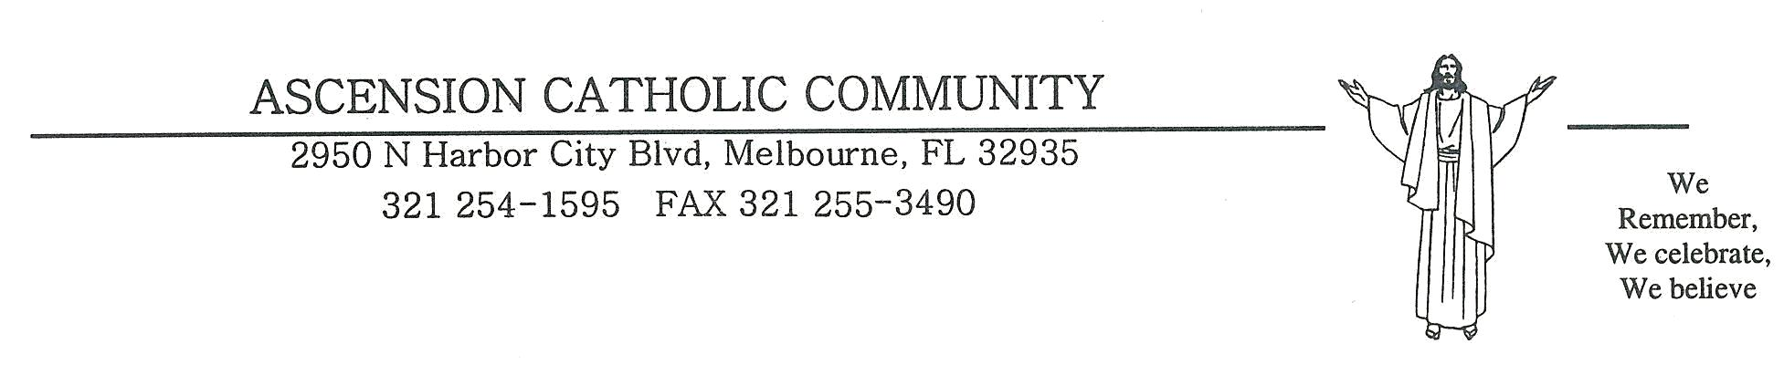

Confirmation Sponsor Certificate
It is the responsibility of the sponsor of the candidate to see that the confirmed person acts as a true witness to Christ and faithfully fulfills the obligations connected with the sacrament.
In order to be a suitable sponsor for Confirmation, Church Law states that a person:
- Be designated by the one to be confirmed
- Must be 16years old or older.
- Be a baptized Catholic in good standing with the church, and must have received the Sacraments of First Eucharist and Confirmation. Signature from pastor required below.
- Strive to live a good Christian life and willing to share his/her faith with the candidate.
- Not be the father or mother of the candidate.
- If the sponsor is unable to attend the ceremony a proxy may be designated.
Affirmation of the Prospective Sponsor
If therefore, you are willing to act as a responsible sponsor and are convinced that you qualify in accord with the conditions listed above, kindly make the following solemn affirmation:
I, (print full name) _______________________________, a practicing Catholic, desire to serve as a sponsor. I solemnly affirm that I fulfill the requirements of the Catholic Church for this role as presented above. I intend, with the grace of God, to continue the practice of my own Catholic faith formation, and I will, to the best of my ability, carry out the obligations of my role as a sponsor.

____________________________________ ________________________________
(Name of Candidate) (Signature of Sponsor)

Affirmation of Sponsor’s Pastor
The above named sponsor is registered (parish name)______________________________ and is eligible to be a Confirmation sponsor.
__________________________________________________________________ ______________________________________ (street) (city, state, zip)
__________________________________________________________________ _____________________________________ (Signature of Pastor) (Date)

